**A Write Up**

Name: Anirudh Hosur

College: VIT Chennai

The task in hand was to identify weather the traffic light was red or green, at that instance.

So, I used OpenCV & python to implement a simple code, which shall classify red and green colors using HSV values.

Step 1 – Load the directory of the video/Image

Step 2 – imread the image/ read the video frame by frame

Step 3 – Introduce HSV color palette, hue saturation value

**For red –**

lower_red = np.array([161,155,84])

upper_red = np.array([179,255,180])

**For green –**

lower_green = np.array(([25,52,72]))

upper_green = np.array([102,255,255])

Step 4 – Create a mask that shall allow only colors of the above-mentioned values.

Step 5 – A bitwise and operator shall add both the mask and original image, to provide only red and green outputs.

Step 6 – Press ‘x’ to destroy the windows and get out of the display.

**OUTPUT –**

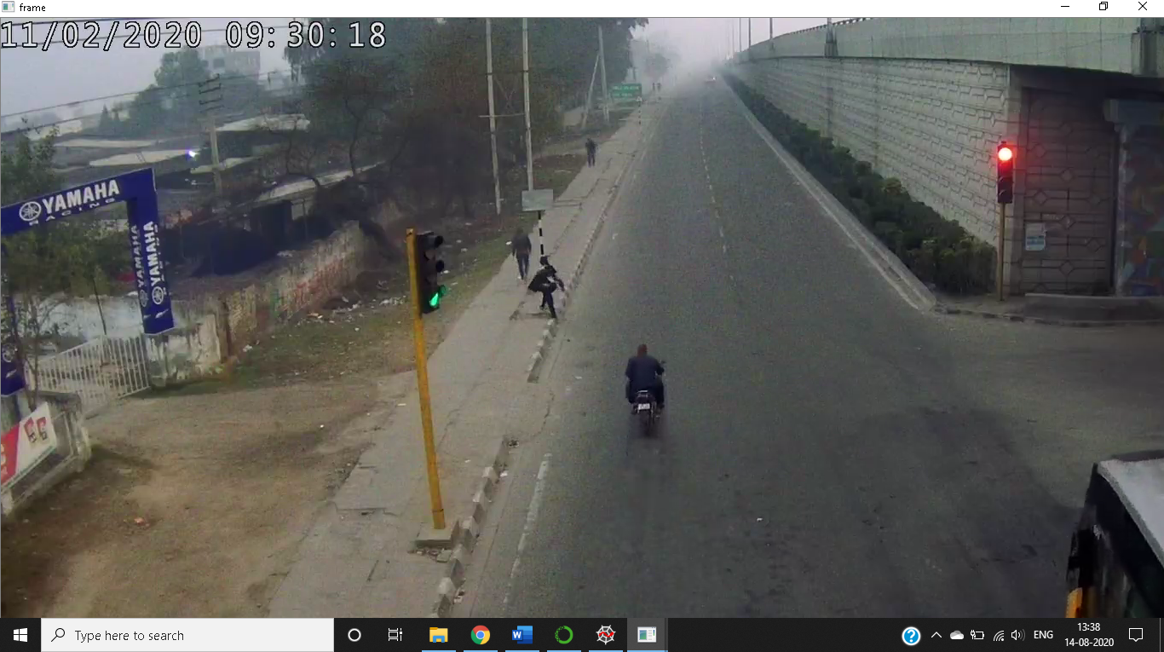

The Hue values for Green is not precise, hence the background distortion.

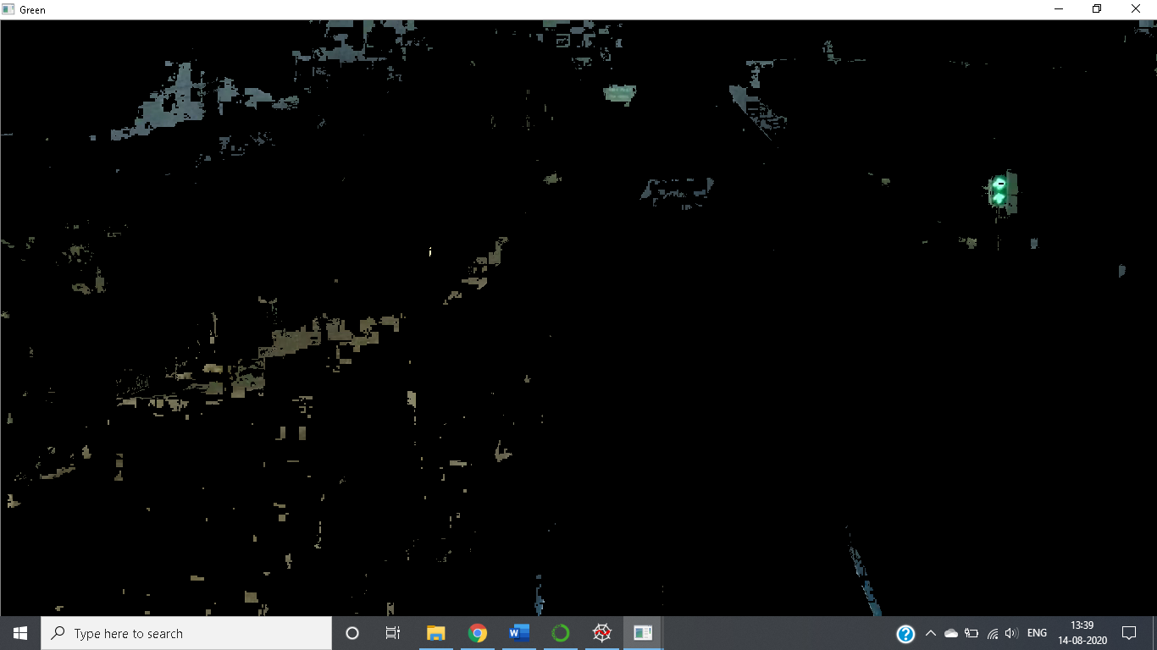

The Hue values for Red are far better than green & precise also.



**REFRENCES –**

<https://www.youtube.com/watch?v=CCOXg75HkvM&list=PLQVvvaa0QuDdttJXlLtAJxJetJcqmqlQq&index=7>